**CHAPTER-1 : OVERVIEW OF THE COMPANY**

* 1. **HISTORY**

TechnoMark is a Mobile, Web, E-commerce and Software Development Company. It was started in 2009. The company is based in Ahmedabad, Gujarat. It serve businesses globally with our penchant for highly robust and scalable business solutions. The Commitment to quality has got them clients in USA, UK, Canada, Australia, India and Other Countries.

**1.2 DIFFERENT PRODUCT / SCOPE OF WORK**

TechnoMark helps businesses create a unique digital identity through premium services in website design and development, mobile app development and software development. A culture of positivity and acceptance. Experience a satisfying career, work-life balance, adherence to a high standard of values and business ethics and be a part of the global workforce. They lead ahead with their three main pillars – Transparency, Commitment and Quality.

**1.3 SERVICES**

TechnoMark provides services like Enterprise Software Solution, Software Development, Mobile App Development, Cloud Native Development, E-commerce Development, Blockchain Development and IoT App Development.

**1.4 FACILITIES**

#### Work from home flexibility

#### Talent-based package

#### Employee bonus

#### Exposure to emerging technologies

#### 5 days working

#### 8:30h shift hours

#### 24 + 10 total leaves

#### Mediclaim benefits

**1.5 SUMMARY**

**Table 1.1: ABOUT TECHNOMARK SOLUTIONS**

| **Website** | https://technomark.io/ |
| --- | --- |
| **Company size** | 850+ employees |
| **Offices’ Location** | Ahmedabad, India  Mumbai, India  Honolulu, USA  Sydney, Australia |
| **Founded** | 2009 |

**CHAPTER-2 : INTRODUCTION TO INTERNSHIP**

**2.1 INTERNSHIP SUMMARY**

As mentioned above, I have got this great opportunity working with many professionals and I got to learn various things during my term of Internship. It was an amazing learning experience for me. During the internship, I got to learn about ASP.NET, MySQL, MVC, Repository Pattern and many more.

**2.2 PURPOSE/ OBJECTIVE**

The purpose of this was to gain the knowledge and experience of the real

world. To know the system better and watch professionals work closely helps you become a better developer as well as it helps you grow your thinking ability and problem solving skills. The reason to do this Internship was to spend some time in knowing the processing and handling the pressure during the releases.

**2.3 SCOPE**

This report is a reflection of the days I have spent at the internship. It has a list of my achievements, activities, and learning, as well as my mental and professional growth. I feel I have improved myself. I am not standing in the place where I was before the internship. I am ahead.

**2.4 INTERNSHIP PLANNING**

* C# Learning
* Learn basic HTML CSS
* ASP.NET Learning
* Introduction to Visual Studio 2022
* Project Resource
* Dependency Injection
* Project in MVC
* Performing CRUD operations
* N-Tier Architecture
* Repository Pattern

**CHAPTER – 3: TOOLS AND TECHNOLOGIES**

**3.1 ABOUT TECHNOLOGY**

The technology assigned to me in this internship was .NET. They provided me with materials to learn .NET from scratch and advanced by referring to that.

**3.1.1 WHAT IS .NET AND C# ?**

.NET is a free, cross-platform, open-source developer platform for building many different types of applications. With .NET, you can use multiple languages, editors, and libraries to build for web, mobile, desktop, games, IoT, and more.

C# is the most popular language for .NET development. With .NET you can target any application type running on any platform. Reuse your skills, code, and favorite libraries across all of them in a familiar environment. That means you can build apps faster, with less cost. From mobile applications running on iOS and Android, to enterprise server applications running on Windows Server and Linux, or high-scale microservices running in the cloud, .NET provides a solution for you.

**3.1.2 WHAT IS HTML ?**

HTML is the language for describing the structure of Web pages. HTML gives authors the means to:

* Publish online documents with headings, text, tables, lists, photos, etc.
* Retrieve online information via hypertext links, at the click of a button.
* Design forms for conducting transactions with remote services, for use in searching for information, making reservations, ordering products, etc.
* Include spread-sheets, video clips, sound clips, and other applications directly in their documents.

**3.1.3 WHAT IS CSS?**

CSS is the language for describing the presentation of Web pages, including colors, layout, and fonts. It allows one to adapt the presentation to different types of devices, such as large screens, small screens, or printers. CSS is independent of HTML and can be used with any XML-based markup language. The separation of HTML from CSS makes it easier to maintain sites, share style sheets across pages, and tailor pages to different environments.

**3.2 INTRODUCTION TO VISUAL STUDIO**

Visual Studio is an Integrated Development Environment (IDE) developed by Microsoft to develop GUI (Graphical User Interface), console, Web applications, web apps, mobile apps, cloud, and web services, etc. With the help of this IDE, you can create managed code as well as native code. It uses the various platforms of Microsoft software development software like Windows store, Microsoft Silverlight, and Windows API, etc. It is not a language-specific IDE as you can use this to write code in C#, C++, VB (Visual Basic), Python, JavaScript, and many more languages. It provides support for 36 different programming languages. It is available for Windows as well as for macOS.

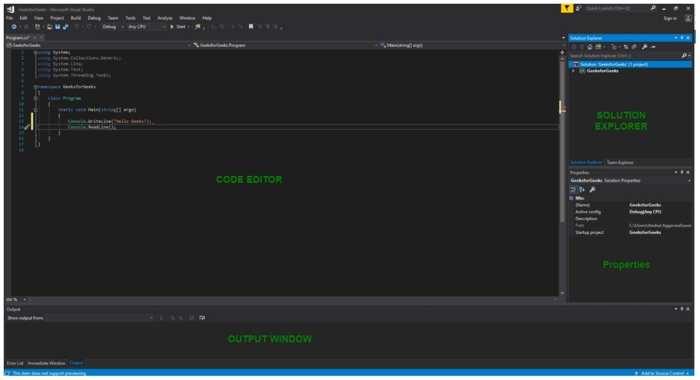

* **Code Editor:** Where the user will write code.
* **Output Window:** Here the Visual Studio shows the outputs, compiler warnings, error messages and debugging information.
* **Solution Explorer:** It shows the files on which the user is currently working.
* **Properties:** It will give additional information and context about the selected parts of the current project.
* **Various Menus in Visual Studio**: A user can find a lot of menus on the top screen of Visual Studio as shown below

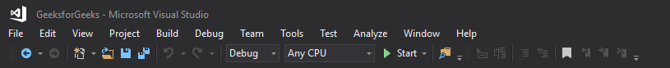

* Create, Open and save projects commands are contained by **File** menu.
* Searching, Modifying, Refactoring code commands are contained by the **Edit** menu.
* **View** Menu is used to open the additional tool windows in Visual Studio.
* **Project** menu is used to add some files and dependencies in the project.
* To change the settings, add functionality to Visual Studio via extensions, and access various Visual Studio tools can be used by using **Tools** menu.

The below menu is known as the toolbar which provide the quick access to the most frequently used commands. You can add and remove the commands by going to **View → Customize**



**Solution Explorer:**

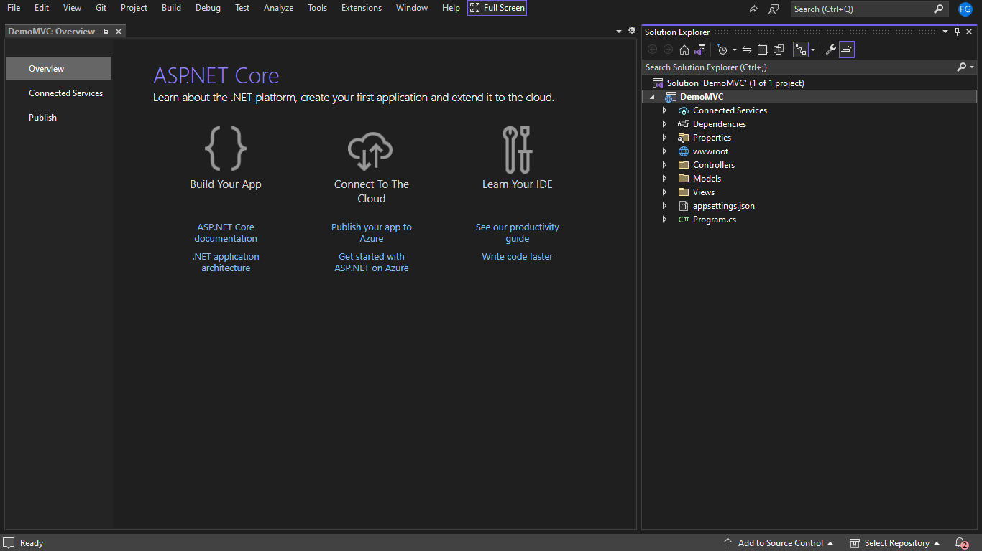

**Dependencies**: All packages and framework store in this folder.

* **Properties:** It is store “LaunchSettings.json” file this file can set all configuration of launch project in which server.
* **wwwRoot:**  All kind of CSS file, JavaScript file and end store extra library.
* **AppSetting:** All of the application’s settings are contained in a file named as appsetting. json
* **Program.cs:** you have to write code of application life cycle and resolve dependencies.
* **Controller:** you have to create controller file for business logic in this folder.
* **Model:** you have to create database table model in this folder.
* **View:** you have to create user and admin view for application in this folder.

**CHAPTER – 4: PROJECT IMPLEMENTATION**

**4.1 PROJECT RESOURCE**

Tools Needed :

* .NET 6
* Visual Studio 2022
* MySQL

**4.2 DEPENDENCY INJECTION**

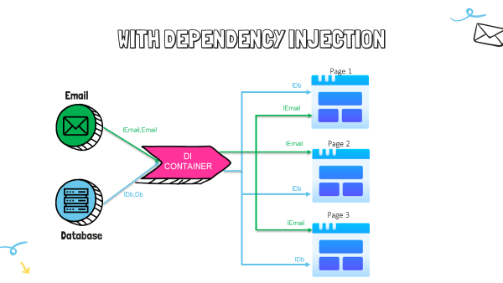

**4.3 PROJECT IN MVC**

**Home Page:**

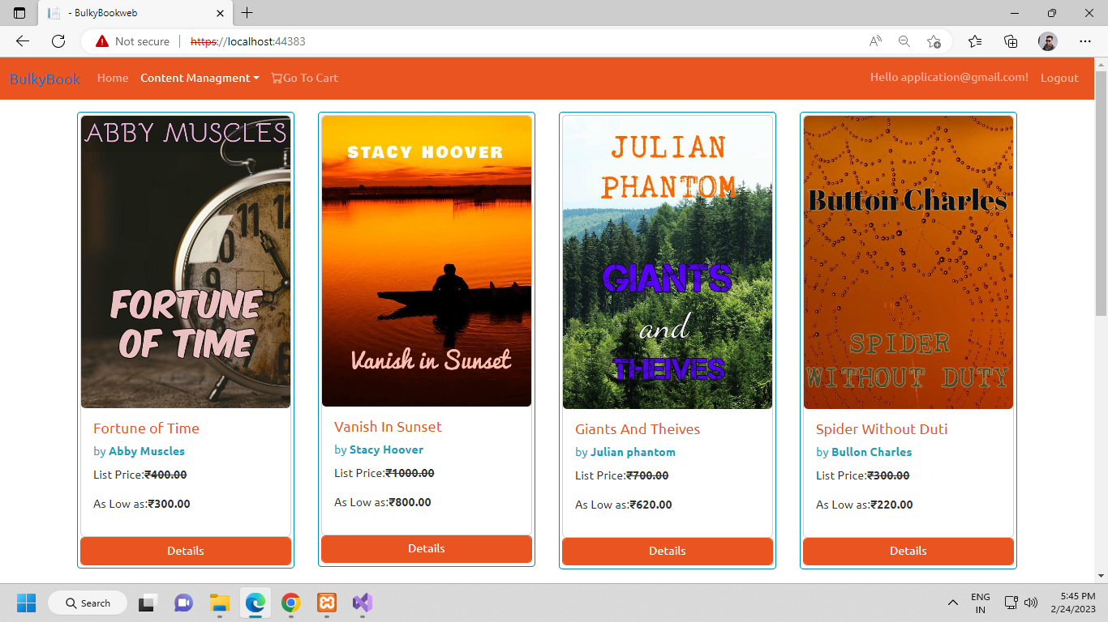

* Home page contain options like: **Content management**, **login**, **logout** and **signup**.
* Also views all products (Books) you want to buy.

**Sign Up:**

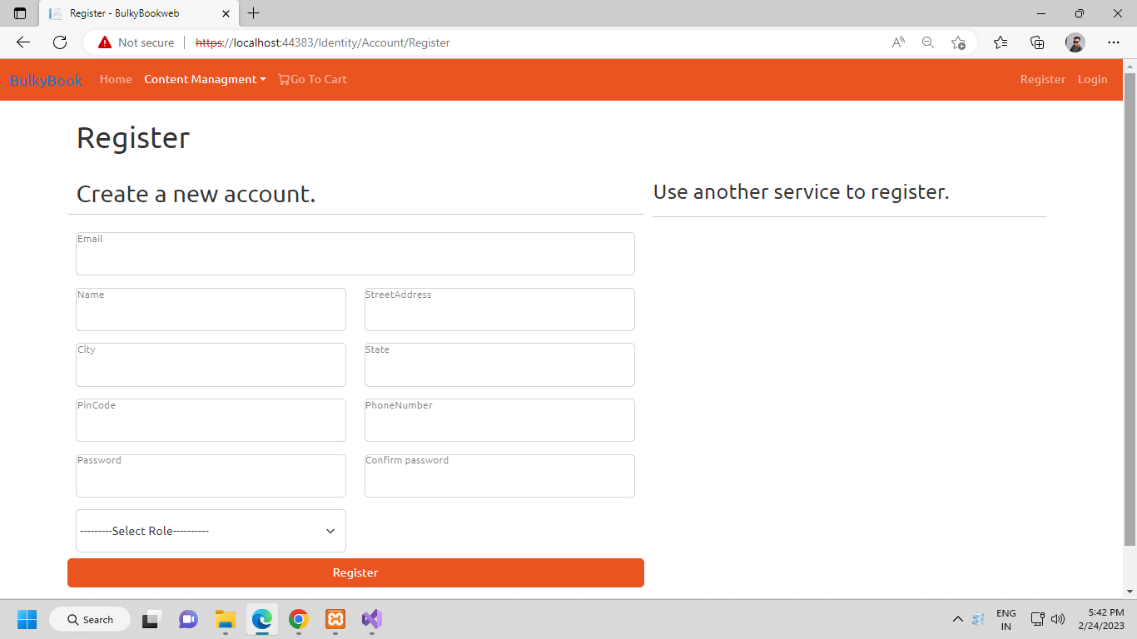

* Signup page contain form fields like: **email**, **name**, **address**, **city**, **state**, **pin code**, **phone number**, **password**, **conform password** and **role**
* **Register** button to submit data in user table.

**Login:**

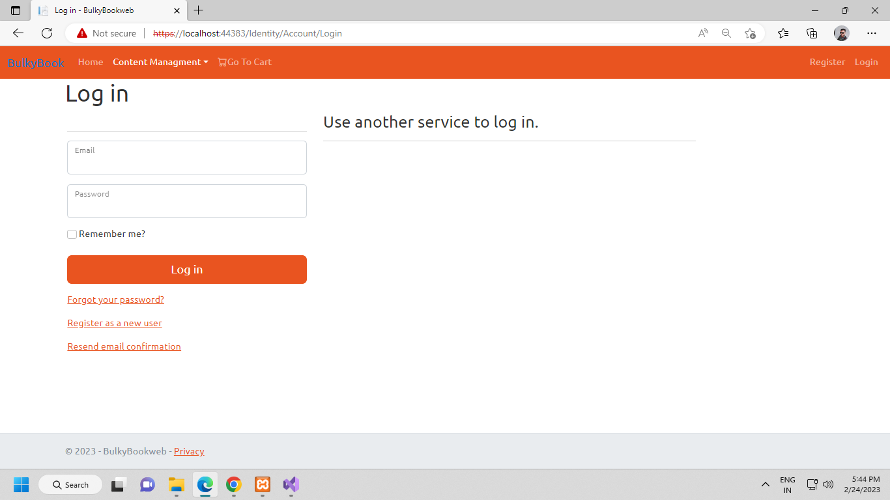

* Login Page with form fields like: **Email** and **Password**.
* Also Remember me option.
* Links for: **Forgot password**, **Register as new user**.

**Category List:**

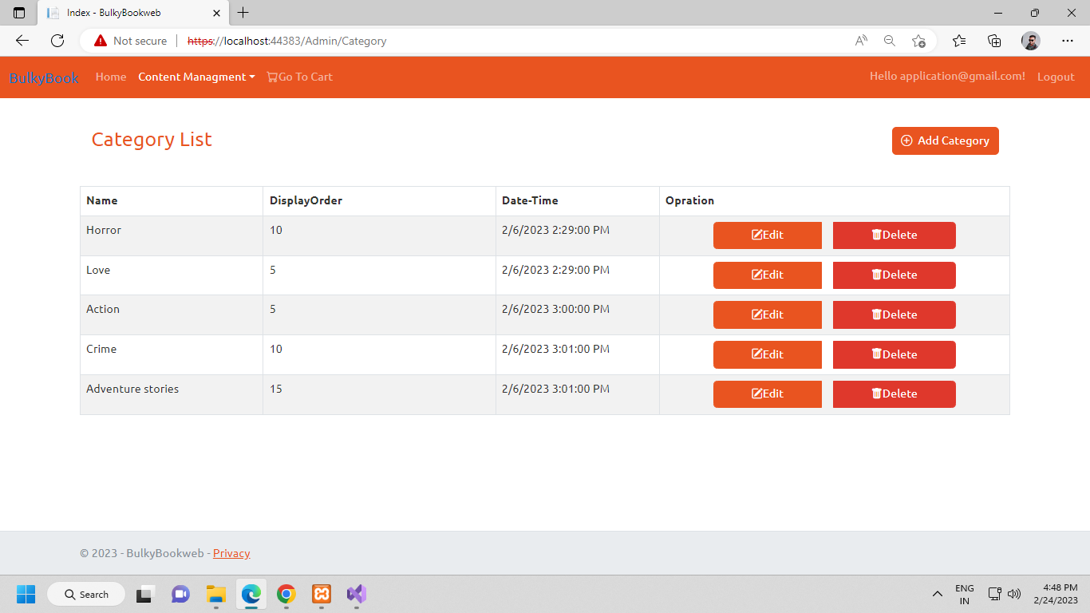

* Category List page shows all the categories in the Table View with fields like: **Name**, **Display Order**, **Date-Time**.
* Also, options to perform action like: **Add category**, **edit category** and **Delete category**.

Categories List Table :

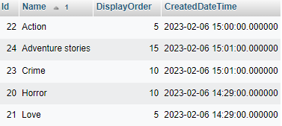

**Add Category:**

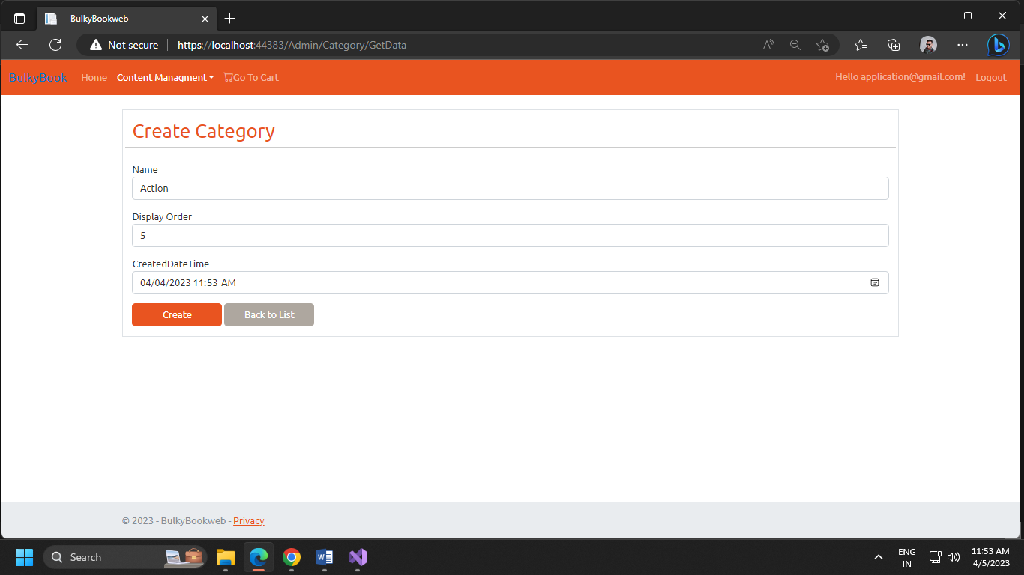

* We can Add new category by clicking on “**Add Category**” button.
* Here we need to fill form fields like: **Category Name**, **Display Order**, **Created Date**.
* Then click on “**Create**” button to create new Category Or Click on “Back to List” button if you want to cancel.

Category Table :

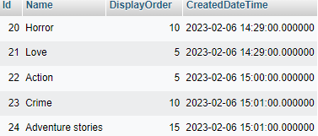

**Update Category:**

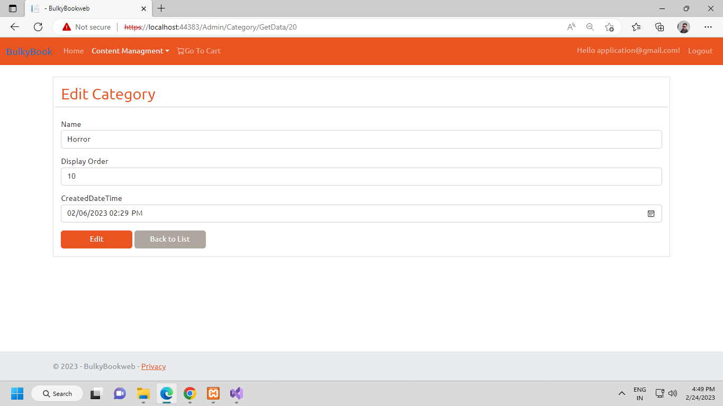

* If you want to Edit any category then, click on “Edit” button on category list page. It will open Edit Category Page with the category details you want to edit.
* Edit the details you want to edit in the form and then Click “Edit” to apply changes.
* Or Click “Back to List” to cancel and go back to category list page.

Category Table for Edit :

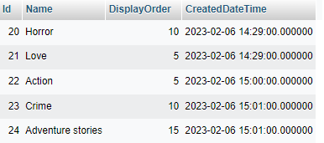

**Delete Category:**

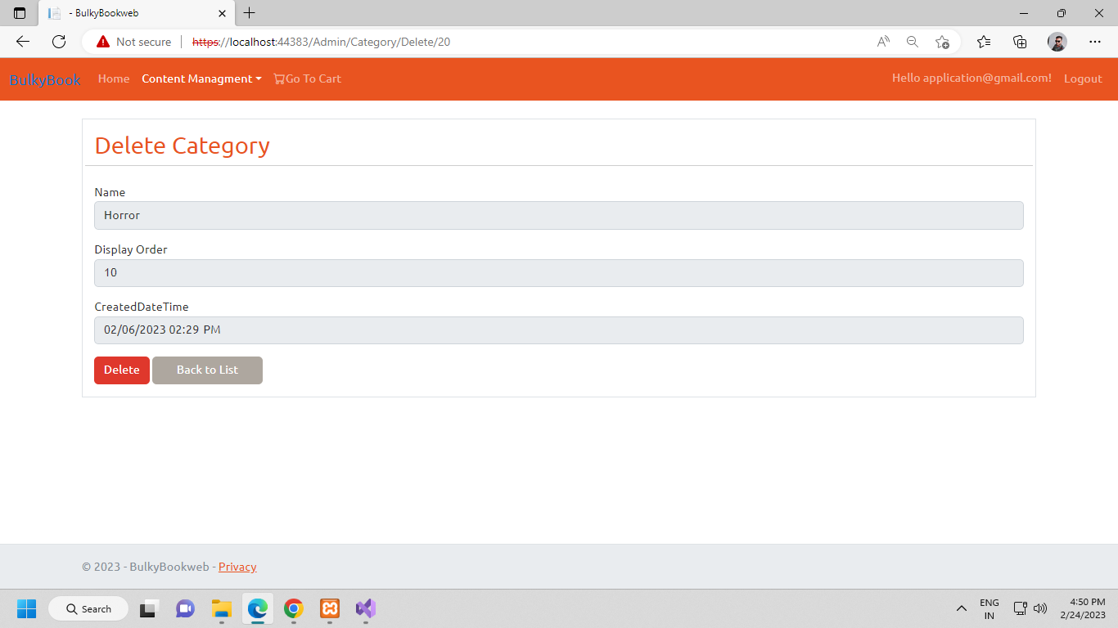

* If you want to Delete any category then, click on “Delete” button on category list page. It will open Delete Category Page with the category details you want to Delete.
* Click “Delete” to apply changes or Click “Back to List” to cancel and go back to category list page.

Categories Table for delete :

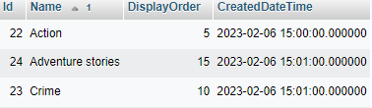

**Cover Type List**

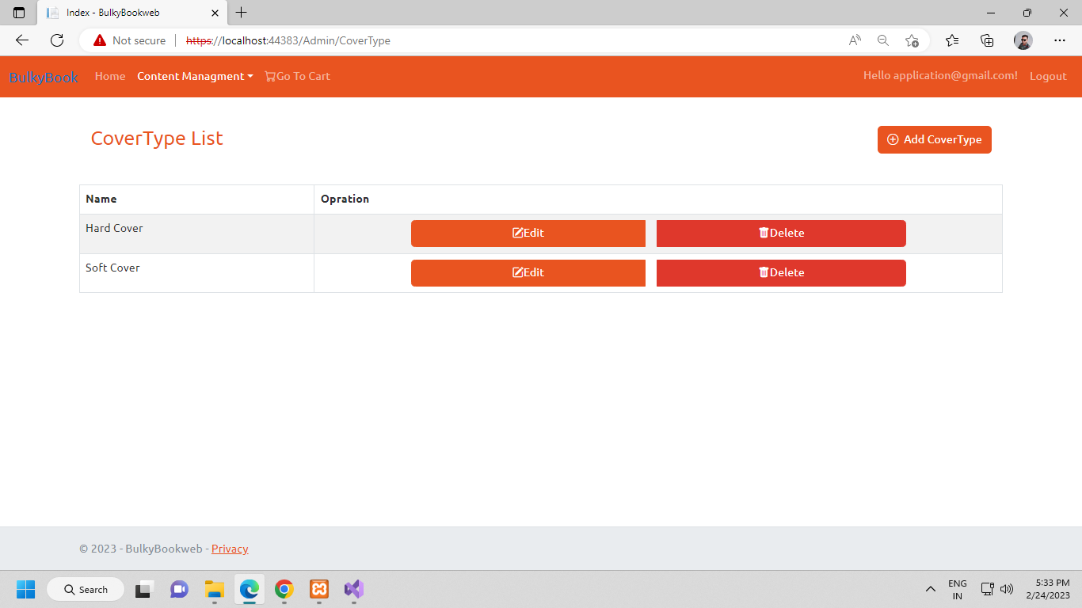

* Cover Type List page show cover type of the books in the Table view with fields like: name and operation.
* Operations contains options to **edit** and **delete**.
* Also “**Add Cover Type**” button to add new book cover type.

Cover Type list Table :

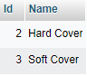

**Add Cover Type**

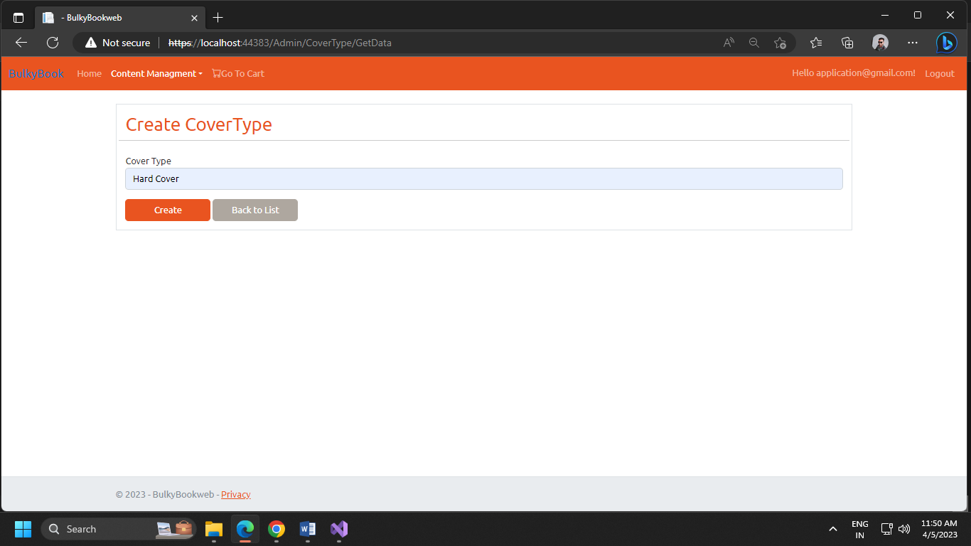

* On Create cover type page we can create new cover type
* Add cover type name.
* Then click “**Create**” to create new cover type or click “**Back to list**” to go back to listing page.

Cover Type Table for Add cover :

 

**Update Cover Type**

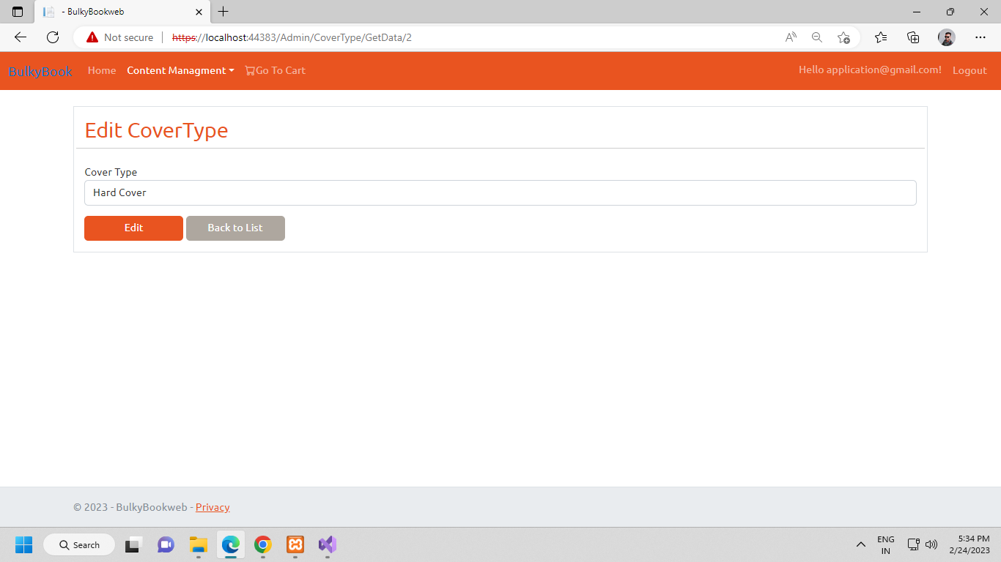

* Edit Cover Type page show details of cover type you want to edit.
* Change cover type name.
* Then click “**Edit”** to apply changes or click “**Back to list**”.

Cover Type table for edit :

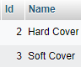 

**Delete Cover Type**

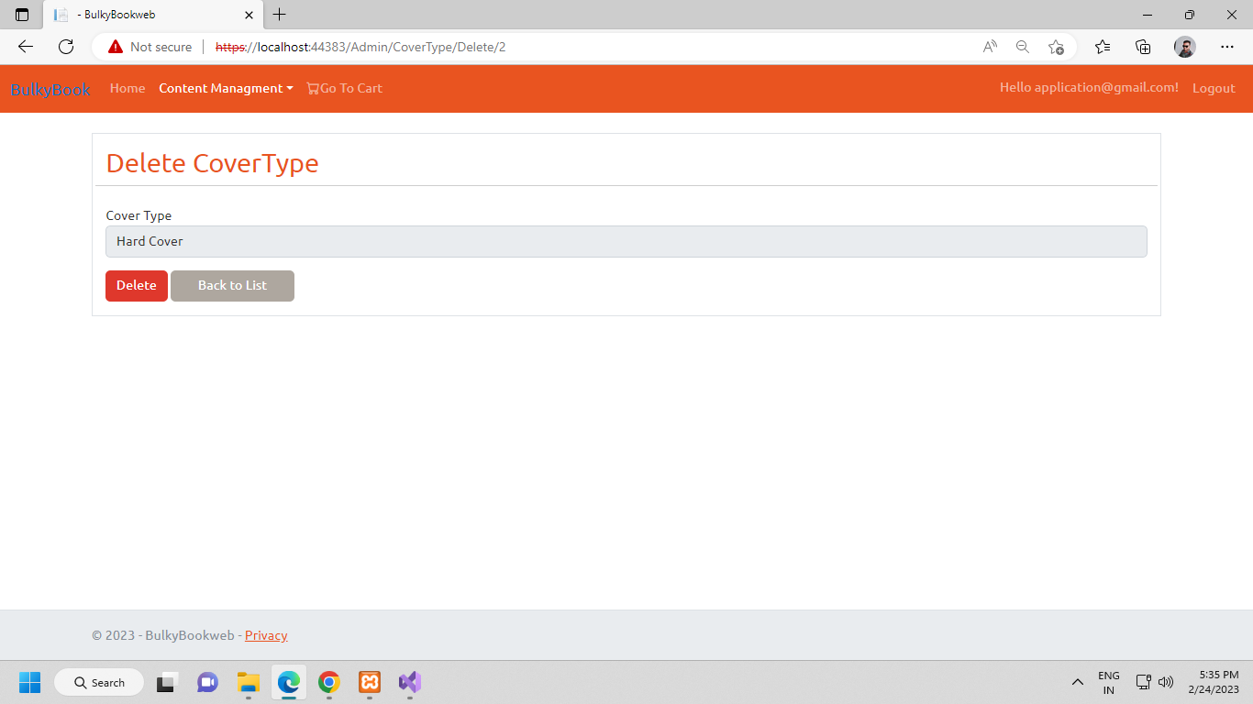

* Delete Cover type page show details of cover type you want to delete.
* Click “**Delete**” to delete covert type or click “**Back to list**”.

Cover type table for delete :



**Product List**

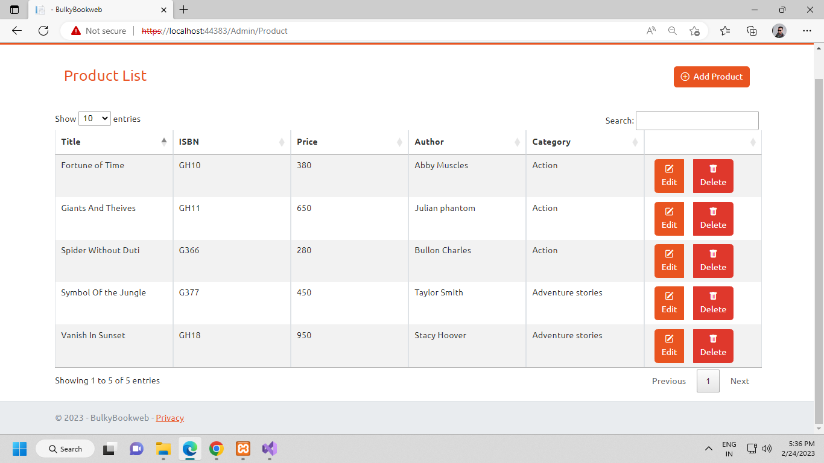

* Product List page show product list with fields like: **Title**, **ISBN**, **Price**, **Author**, **Category** and **Operation**.
* You can **search** product and **filter** product.
* Also perform actions like: **Add product**, **Edit** and **Delete** product.
* Pagination with data table.

Product list table :

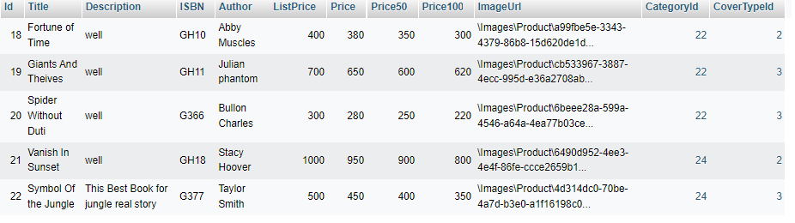

**Add Product**

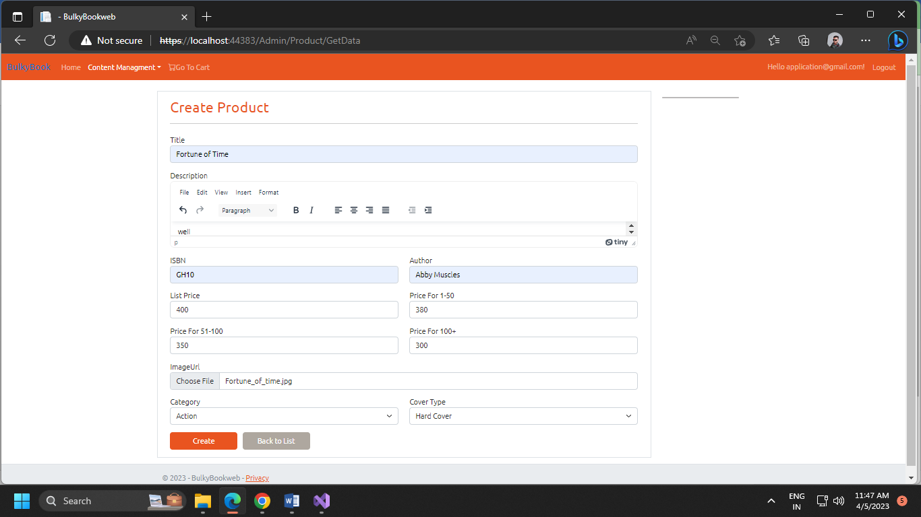

* Click **“Add product**” to create new product.
* Fill form details like: **Product title**, **Description**, **ISBN**, **Author**, **List price**, **Price for (1-50)**, **Price for (51-100)**, **Price for (100+)**, **Image URL**, **select category** and **select cover type.**
* Then click “**Create**” to add new product or click “**Back to List**” to go back.

Product table for add :

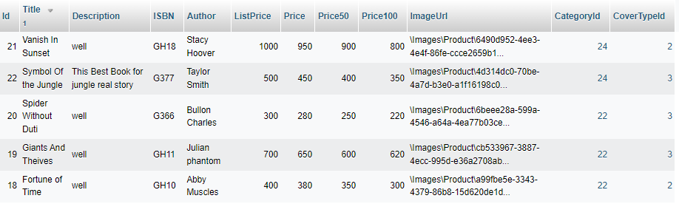

**Update Product**

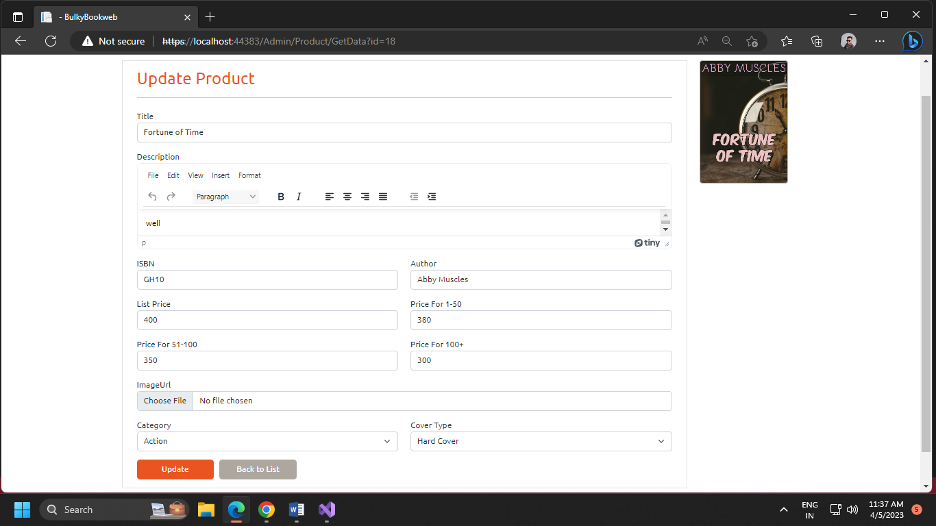

* Update product page show product details to update product details.
* Change the field data you want to update.
* Then click “**Update**” to apply changes or click “**Back to list**” to go back.

Product table for edit :



**Delete Product**

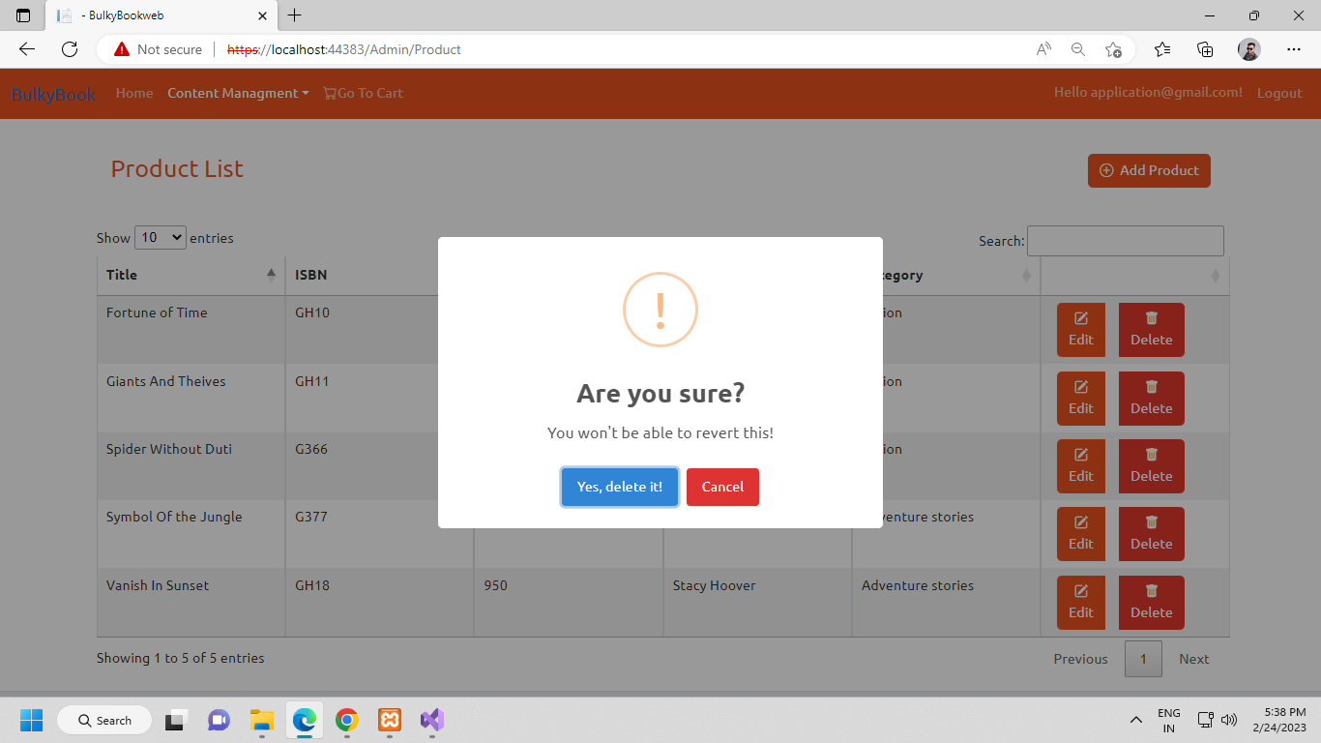

* By Clicking “**Delete**” alert popup appears for confirmation to delete the product.
* Click “**Yes, delete it**” to delete product or “**Cancel**” if you want to cancel delete.

Product table for delete :



**Product Details**

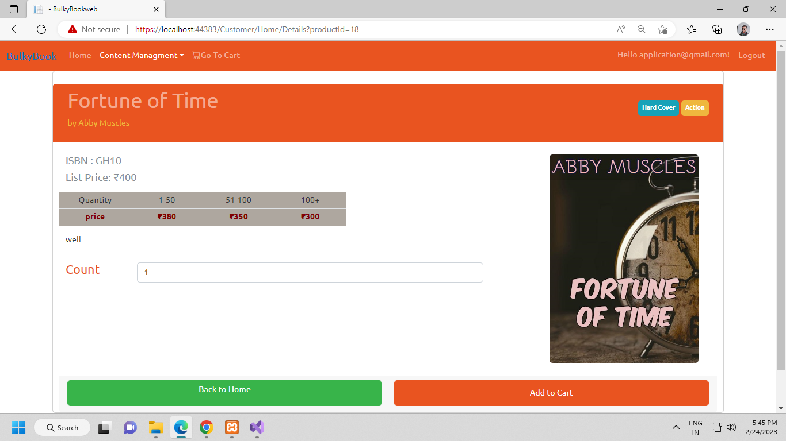

* Product summary page show details of selected product with **ISBN No**, **List Price**, **Product price** based on quantity.
* Also, option like: **Add to cart** and **back to home.**
* We can add Product in cart by clicking “**Add to Cart**”.

**Cart View**

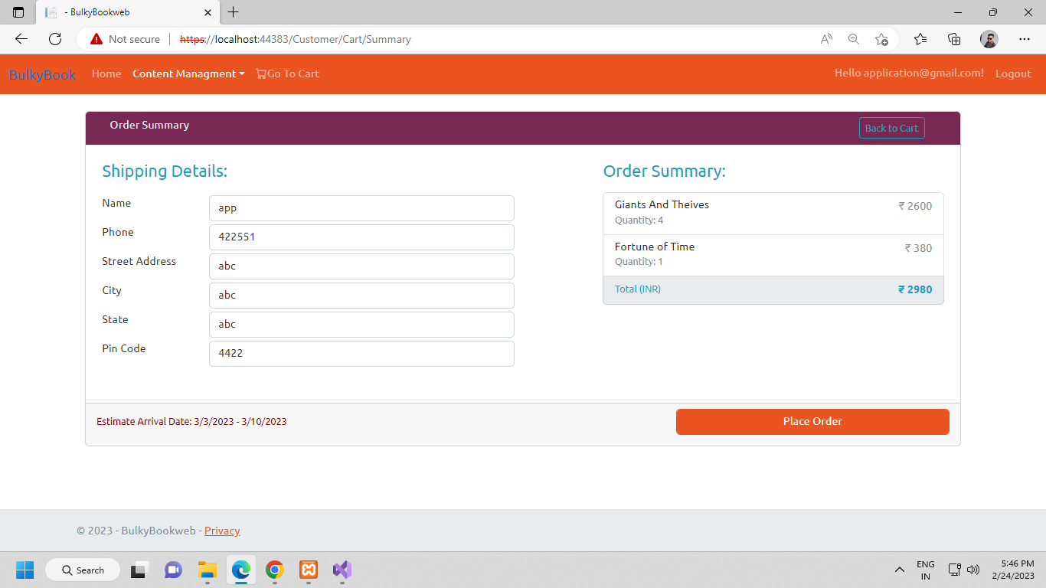

* Cart page show form to fill **Shipping details** and the **Order Summary** of the product you have added in the cart.
* Click on “**Place Order**” to place order the provided shipping address or click “**Back to home**” to go back.

**N-Tier Architecture in MVC**

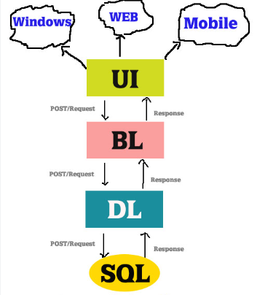

* N-tier architecture is also known as 3-tier architecture.
* N-tier architecture includes a presentation tier, a middle-tier, and a data tier.
* The middle tier typically includes a data access layer, a business logic layer, and shared components such as authentication and validation.
* The data tier includes a relational database.
* N-tier applications usually store sensitive information in the data access layer of the middle-tier to maintain isolation from end users who access the presentation tier.

**Repository Design pattern**

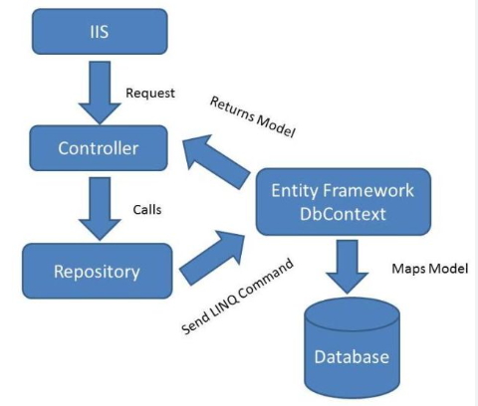

* A Repository pattern is a design pattern that mediates data from and to the Domain and Data Access Layers (like Entity Framework Core / Dapper / LINQ).
* Repositories are classes that hide the logics required to store or retrieve data. Thus, our application will not care about what kind of ORM we are using, as everything related to the ORM is handled within a repository layer.

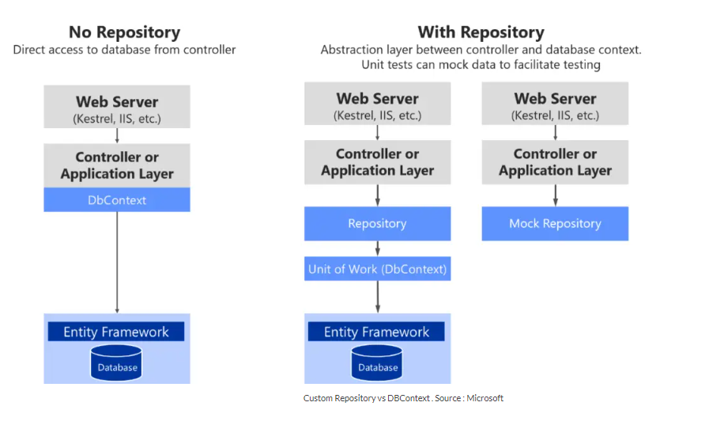

**CHAPTER-5 : CONCLUSION AND DISCUSSION**

**5.1 OVERALL ANALYSIS OF INTERNSHIP**

The experience I had during this Internship was extremely amazing and effective. I can feel myself grow and get better during each day of Internship. I got to learn something new during each day of this time period. The work environment was very good. I also got better at communication skill and personality development.

Overall, my internship at Neofruition has been a success. I was able to gain practical skills, work in fantastic work environment, and gain some amazing knowledge from really experienced and innovative people.. I could not be more thankful.

**5.2 SUMMARY OF INTERNSHIP WORK EXPERIENCE**

Throughout this internship, while working in TechnoMark Solutions, the knowledge that I gained during this period of time has helped me to understand the coding better. Also to handle the pressure during time limits and release times, it was a great learning experience and I see these duration of time spent at TechnoMark Solutions as best spent.

**REFERENCES**

*The listing of references should be typed 4 spaces below the heading “REFERENCES” in alphabetical order in single spacing left – justified. The reference material should be listed in the alphabetical order of the first author. The name of the author/authors should be immediately followed by the year and other details.*

Website citation has to be very specific not like ‘**google.com**’ or ‘wikipedia.org’.

Figure copied from some paper or website has to be captioned with “**Courtesy of**

**_** ”

A typical illustrative list given below relates to the citation example quoted above.

***Remove this Paragraph and above line after adding List of REFERENCES***